# **Project overview**

This project features an Excel file designed as a staffing tool to enable managers to allocate personnel time across various projects. The unit of measurement used throughout is Person-Month (PM), a common metric in management. To achieve a balance between clear visualization and ease of editing, while maintaining the practicality of a database table, I developed a custom editable kind of pivot table system that works with macros to load and save data to the database table.

The file incorporates several safeguards to minimize human errors, including within the macros and through color-coding. For example, the tool can handle changes in work regimes, even if they occur mid-year, thereby accurately displaying the maximum number of PMs a person has available annually.

The tool's easy-editing capability is crucial for adapting to unforeseen changes, such as a project extension, an employee leaving the company, switching to a part-time contract, … allowing managers to quickly assess impact and reallocate resources as needed.

Note that you will need Excel 365 to read this file properly as it uses the latest features.

# **User’s guide**

## **General principles**

All the cells highlighted in can be edited

All the cells highlighted in  means there is something unusual that needs the user’s attention (more details in each tab’s description)

All the cells that are not meant to be edited in a standard use of the file are locked.

## **Projects**

Any project needs to be added to the ‘Project List’ tab, else you won’t be able to load its data in the view tabs.

This tab contains a few fields as show below, but the mandatory fields to fill for the file work properly are **‘Project’, ‘Start’** and **‘End’**



## **Personnel**

Any staff member that you want to consider for the staffing needs to be in the personnel list.

To view all the persons already in the personnel list, you can go in the ‘Personnel View’ tab and open the drop-down menu in cell B1

To add a person to the list, you need to go into the ‘Personnel updates’ tab and fill the ‘Add/Edit Personnel’

Note that the mandatory fields are **‘Full name’, ‘Start date’** and **‘Starting Work Regime’** (a 100% work regime = a full-time contract, 80% = 4/5 part time contract, etc.)

If the name you enter in ‘Full name’ is already in the list, then the information you enter in this form will Edit the data of that person in the Personnel List.

If you want to register that someone left the company, then please look at the ‘Work Regime’ section below.

## **Work Regime**

Each person’s work regime data is used to calculate their max PMs per year (used in the 3 view tabs).

In case a team member changes his/her work regime during his/her contract, you can register this information through the ‘Personnel update’ tab, in the ‘Edit Work Regime’ form.

Once you have entered the name of the person, you will see below the form a summary of all the work regime changes that are already in the database.

To add a new work regime change to the list, you need to fill the new work regime percentage in the ‘Work regime’ field, and the date of the change in the ‘Date’ field, then click ‘Add/Edit’.

To edit an already existing work regime change, you need to fill the updated work regime percentage in the ‘Work regime’ field, then enter the same date as the date of the work regime change you wish to edit in the ‘Date’ field and click ‘Add/Edit’

*Example to edit the 1/10/19 work regime change from 50% to 60%:*

*then click ‘Add/Edit’*

To delete an existing work regime change, you need to enter the same date as the date of the work regime change you wish to delete in the ‘Date’ field and click ‘Delete’

*Example to delete the 1/7/20 work regime change:*

*then click ‘Delete’*

To register a person leaving the company, you need to register a 0% work regime line on the date of their leave.

## **The 3 view tabs**

In those 3 tabs, you can view and edit the PMs of all the team members through 3 different views. This is the same data source behind those 3 views, thus any change saved in one of those view will be reflected in the others.

In each tab, if a person is overbooked, a warning message will appear, even if this doesn’t concern the selected year/project/person.

### **Year view**

**General principle:**

In this view, you can see and edit all the data related to a specific year, for all the projects and persons involved.

**Color code**:

If a person’s Max PMs, remaining PMs and total PMs are highlighted in , this means that this person has too many PMs allocated for that year

If a project is highlighted in , this means that this project should be finished / shouldn’t have started if we refer to the starting/ending date of that project.

**View or edit data:**

1. Select the target year in cell B1
2. Click the “Load Data” button
3. Make your modifications in the table
4. Click the “Save changes” button

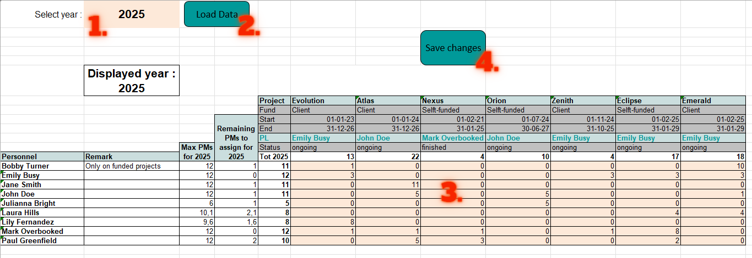

**Additional notes:**

* If you want to add PMs to a person that is not already in the loaded list, you can simply enter the name of that person below the last entry in the ‘Personnel’ column. Note that the person needs to have already been added to the personnel list (done through the ‘Personnel update’ tab)
* If you want to take out a person’s line, you simply need to put all his PMs to 0, and once you click the ‘Save changes’ button, the line will be deleted.
* By default, all the projects that are running in that year + all projects that have PMs allocated to it for that year will be loaded. If you still want to add a project (for example a finished or a not yet started project), you can simply enter the name of that project on the right of the last project in the ‘Project’ line.
* If you want to modify a project’s general data (start, end, project leader etc), you will need to do it through the ‘Project view’ tab or directly in the ‘Project List’ tab.
* If you want to modify a person’s general data (remark, division, role etc), you will need to do it through the ‘Personnel view’ tab or through the ‘Personnel update’ tab.

**Special case:**

If you load a year in which there is no running project and/or no one assigned, you will see #CALC! errors:

The process to add a person and a project is the same as described above, you just need to do it below / on the right of the #CALC! error:

Once you will have clicked the ‘Save changes’ button, the #CALC! errors will disappear:

### **Project view**

**General principle:**

In this view, you can see and edit all the data related to a specific project, for all the duration of the project and persons involved.

To be able to verify how many PMs are available for each person in each year, there is a ‘Currently available PMs’ table on the right of the sheet. It displays all the PMs available by person and by year, excluding the PMs of that specific project. Thus, the numbers displayed in that table is the maximum number of PMs that you can assign to that project.

**Color code**:

If a person’s available PMs is highlighted in , this means that the PMs allocated to the project is over that person’s total available PMs

*With corresponding allocation table :*

If a year is highlighted in , this means that this year isn’t inside the project duration.

**View or edit data:**

1. Select a project in cell B1
2. Click the “Load Data” button
3. Make your modifications in the project’s general data if needed
4. Make your modifications in the table
5. Click the “Save changes” button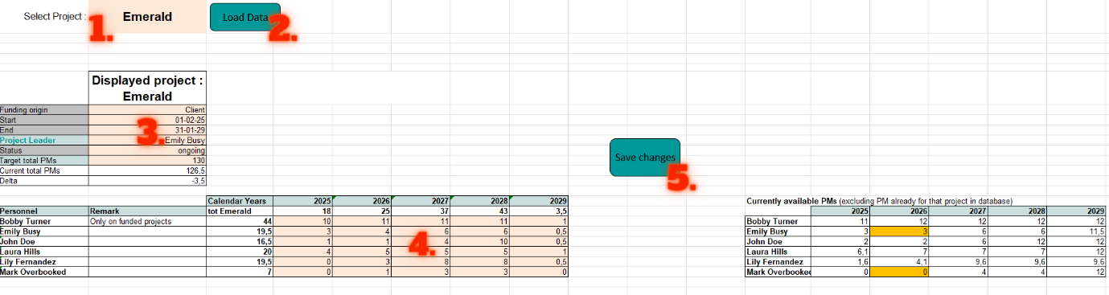

**Additional notes:**

* If you want to add PMs to a person that is not already in the loaded list, you can simply enter the name of that person below the last entry in the ‘Personnel’ column. Note that the person needs to have already been added to the personnel list (done through the ‘Personnel update’ tab)
* If you want to take out a person’s line, you simply need to put all his PMs to 0, and once you click the ‘Save changes’ button, the line will be deleted.
* By default, all the years within the project duration and any additional years for which PMs are allocated to the project will be loaded. If you want to add a year outside the listed years (for example after the finish or before the start), you can do so by entering that year immediately following the last year in the ‘Calendar Years’ line.
* If you want to modify a person’s general data (remark, division, role etc), you will need to do it through the ‘Personnel view’ tab or through the ‘Personnel update’ tab.
* Any project that covers more than 8 years won’t work in this view, because the ‘Currently available PMs’ table would interfere. If there is any project longer than that, you either can manage it through the other view tabs (Year view & Personnel view) or you can split the project in parts that are shorter than 8 years.

**Special case:**

Similarly to the Year View tab, if you load a project in which there is no one assigned, you will see #CALC! errors. To add a person, you can just enter his name below the #CALC! error (see ‘Special case’ of the ‘Year View’ section of this file if you need more details).

### **Personnel view**

**General principle:**

In this view, you can see and edit all the data related to a specific person, for any year and any project.

**Color code**:

If a year’s Max PMs and total PMs are highlighted in , this means that the selected person has too many PMs allocated for that year.

**View or edit data:**

1. Select a person in cell B1
2. Click the “Load Data” button
3. Make your modifications in the person’s general data if needed (note that any change to the work regime needs to be done through the ‘Personnel updates’ tab)
4. Make your modifications in the table
5. Click the “Save changes” button

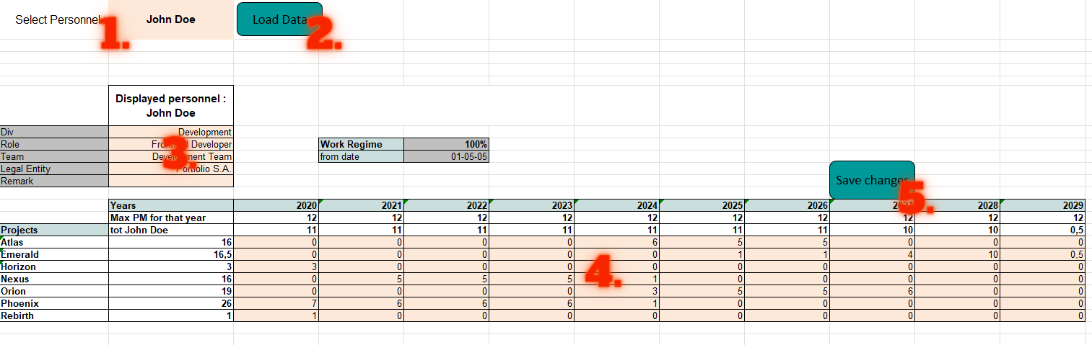

**Additional notes:**

* If you want to add PMs to a project that is not already in the loaded list, you can enter the name of that project below the last entry in the ‘Projects’ column. Note that the project needs to have already been added to the project list (done through the ‘Project list’ tab)
* If you want to take out a person’s line, you simply need to put all his PMs to 0, and once you click the ‘Save changes’ button, the line will be deleted.
* If you want to add a year outside the listed years, you can do so by entering that year immediately following the last year in the ‘Years’ line.
* If you want to modify the work regime data of a person, it can be done exclusively through the ‘Personnel updates’ tab

**Special case:**

Similarly to the Year View tab, if you load a person who isn’t assigned to any project yet, you will see #CALC! errors. To add a project, you can just enter the project’s name below the #CALC! error (see ‘Special case’ of the ‘Year View’ section of this file if you need more details).